**ECE 445**

Fall 2023

Team 13 Design Document

Tesla Coil Guitar Amp

Griffin Rzonca & David Mengel

TA Mentor: Jason Paximadas

**I. Introduction**

**Problem:**

Musicians are known for their affinity for flashy and creative displays and playing styles, especially during their live performances. One of the best ways to foster this creativity and allow artists to express themselves is a new type of amp that is both visually stunning and sonically interesting. Musical tesla coils have been used for performances in the past, showing there is a market for devices like this [1] . Though, these often use premade music files or are computer-controlled, and do not have the ability to take live input from instruments. Giving these coils the ability to take live input from a musician to create music will open up a new world of possibilities for musical expression and exciting live performances.

**Solution:**

Our design is a guitar amp that uses a tesla coil to create a unique tone and dazzling visuals to go along with it. The device will take the input from an electric guitar and use this to change the frequency of a tesla coil's sparks onto a grounding rod, creating a tone that matches that of the guitar.

**Visual Aid:**

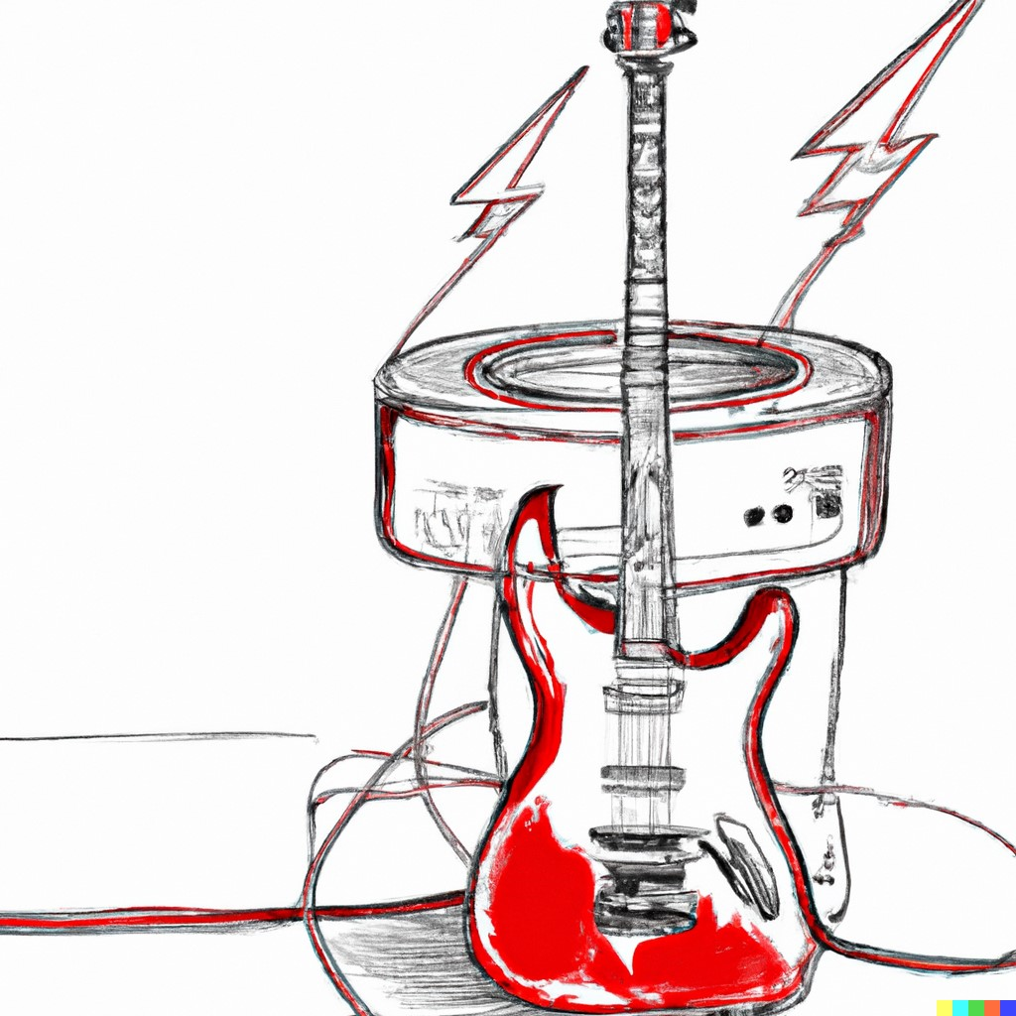

***Figure 1: Visual Aid***

**High-Level Requirements:**

There are three primary requirements that this design must fulfill in order to be considered successful:

1. The tesla coil can produce visible sparks roughly 5cm in length
2. The coil can produce several different notes in the range 50Hz - 2kHz
3. The coil can take input from the guitar to determine the notes played

**II. Design**

**Block Diagram:**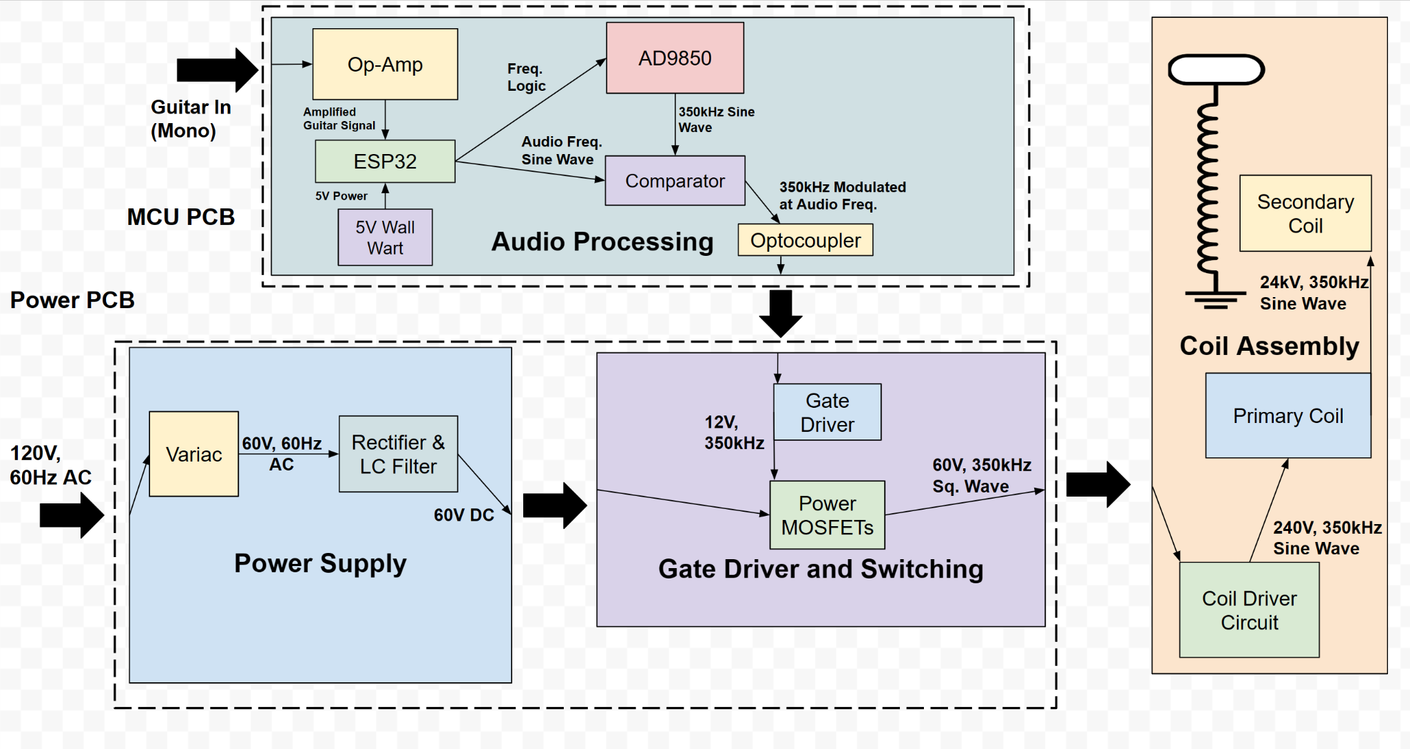

***Figure 2: Block Diagram***

**Audio Processing:**

The audio processing system will convert the output of the guitar into a pulse wave that will control the gate drivers, ultimately allowing power to be passed into the coil at the desired frequency. This can be done using some op-amps for input processing, a microcontroller and frequency driver for high-frequency generation, and a comparator for generating a PWM waveform. In order to operate our tesla coil, we need to drive it at its resonant frequency. Initial calculations and research have this value somewhere around 350kHz. We will use the ESP32 microcontroller, which will send a signal to an AD9850 frequency generator in order to create signals at the resonant frequency.

The system will operate by taking the guitar input through an audio jack, which will then be amplified by an op-amp and sent to a comparator for processing. The ESP32 will then send a signal to the AD9850 telling it to generate a signal at the resonant frequency, which will be sent into the other side of the comparator. In order to output different notes, we plan to use pulse-width modulation (PWM): modulate the resonant frequency with the frequency of the desired audio note. Furthermore, the subsystem is dual populated to make the design more robust. In addition to PWM, the audio processing subsystem is also equipped to simply use the comparator to combine the two signals, with the ESP32 providing a square wave at the audio frequency and the AD9850 providing a square wave at the resonant frequency. This alternative would effectively act as a logical “AND”, creating pulses of the resonant frequency, where the pulses occur at the frequency of the desired audio note. For example, an A note corresponds to around 110 Hz, so, to “play” an A note, the subsystem can either create pulses of the resonant frequency 110 times per second, or it can use PWM to modulate the resonant frequency signal with the 110 Hz signal to create a tone. PWM is preferred as it will lead to higher audio fidelity, with the output mimicking a sine wave, as opposed to the effective “AND” operation, which would mimic a square wave. The extra layer of resilience is included to ensure functionality. We would like the high-frequency pulse wave output to be within 500 Hz of the resonant frequency, due to the frequency response of the coil assembly. The reason for this will be elaborated on in the tolerance analysis portion of the document. The output waveform will then be sent through an opticoupler in order to provide isolation between the signal processing circuitry and the power circuitry, protecting the circuit and the user. Ultimately, the output of this system will be used to control the gate driver circuitry, which will control a network of MOSFETs to pass power into the tesla coil assembly at the desired frequency and waveform.

*Requirements Table:*

| **Requirement:** | **Verification:** |
| --- | --- |
| Output pulse wave must be at resonant frequency in range 100k-400kHz with 500Hz granularity | Measure waveform frequencies with an oscilloscope |
| Subsystem must output a signal of 5 ± 1V to the gate driver and switching subsystem | Use voltage probe to measure output |
| Subsystem can create a pulse wave that is either pulses of the resonant frequency or a PWM wave where the resonant frequency is modulated with the audio frequency | Duty cycle can be measured using an oscilloscope to determine the ratio of the time the circuit is on vs off |

**Power Subsystem:** The system will draw power from AC mains wall voltage, at 120V. To generate sparks on the coil, we need to drive our circuit at its resonant frequency, which will be around 355kHz. Since the wall power is 120V at a 60Hz frequency, we will use a Variac to step the voltage down to a safer 60V. Then, we will use a DB35-10 full-bridge rectifier to rectify the AC waveform into DC. Then, we will use several ceramic capacitors totaling 1000µF in parallel with the voltage source, and a 100mH inductor in series to filter this signal to a steady 60V DC. Then, this 60V DC signal will be passed to our switching subsystem to generate an AC waveform at the resonant frequency. LtSpice simulations predicted around 10A of current at 60V coming out of the power subsystem and going into the switching subsystem. A circuit schematic with power, filtering, and switching is shown below:

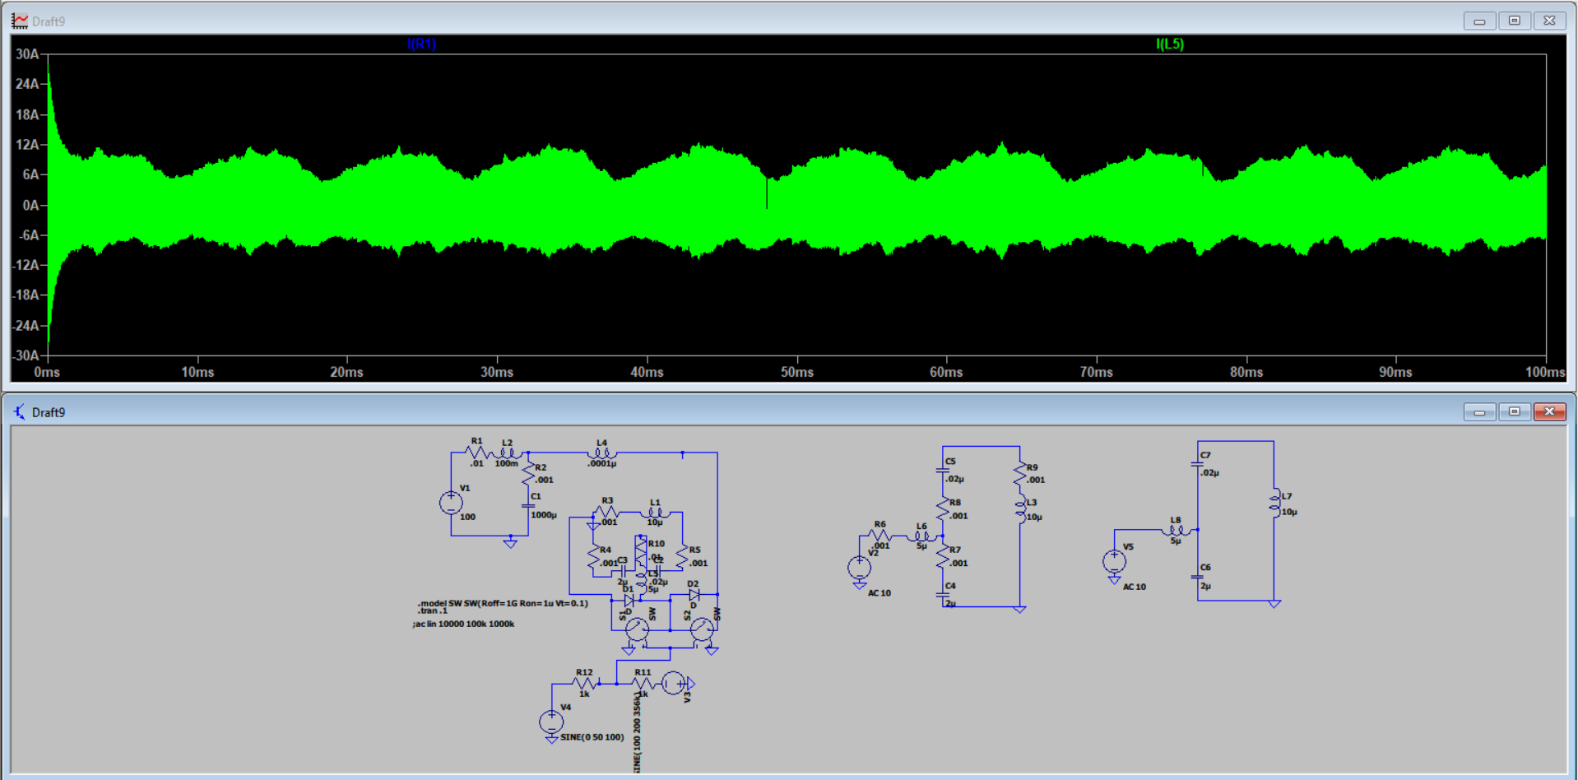

***Figure 3: Power Circuit Diagram***

*Requirements Table:*

| **Requirement:** | **Verification:** |
| --- | --- |
| After filtering, limit ripple voltage to 10% | Measure waveform with oscilloscope and observe the min to max voltage variation |
| Voltage sent to switching must be able to reach at least 60V, and any value lower | Monitor using oscilloscope or DVM |
| Circuit must be able to limit DC input current to to 10 ± 5A | Monitor using oscilloscope |
| Subsystem must not trigger wall outlet circuit breaker: max wall outlet power is 1.5kW[2], so limit power consumption to below 1.5kW | Monitor outlet to ensure breaker is not triggered |
| Capacitors must be discharged to below 10 volts 5 minutes after coil power is disconnected | Install bleeder resistors on capacitors and use voltage probe to test capacitor voltage |

**Gate Driver and Switching Subsystem:**  
 This subsystem will take input from the audio processing subsystem and use it to control gate drivers, which will allow the MOSFETs to send power to the coil at the desired frequency waveform. It will also take input from the power subsystem, which will provide the voltage that the MOSFETs will be switching on and off. The gate drivers will use a 12V wall wart power supply to power the logic, and control the MOSFETs by outputting 10-12V between each FET’s gate and source. We will use the SI82394CD4-IS gate driver, because of its 12V output capabilities and the fact that it is galvanically isolated, which provides an additional layer of protection for the rest of the circuit from the power rail. The gate driver will also include an external resistor on the order of 1-5Ω, depending on what is experimentally found to be most effective. This resistor is included to counteract the inductive ringing seen as the MOSFETs are turned on. By including a resistor on the gate driver’s output, the ringing is limited, however this comes at the expense of lengthening the turn-on time by a small amount which can be determined experimentally.

The goal of the switching circuitry is to send a square wave to the coil assembly system. The switches will take the rectified DC voltage from the power subsystem and a turn-on signal from the gate drivers in order to operate. The switches will consist of two parallel branches of power MOSFETs to turn the 60V DC input signal into a square wave at around 350kHz. For MOSFET selection, we will use the Infineon STW65N65DM2AG due to its high current and voltage ratings of 60A and 650V, respectively. Its low resistance of around 50mΩ also allows us to minimize losses. The MOSFETs will be driven at the resonant frequency, calculated to be around 350kHz according to the LtSpice simulation. The model of MOSFET selected has a 13.5ns rise time and a 11.5ns fall time, with turn-on and turn-off delays of 33 and 114ns, respectively. These short delay times should be suitable for the intended driving frequency of around 350kHz.

*Requirements Table:*

| **Criteria:** | **Verification:** |
| --- | --- |
| Limit Current Spikes through subsystem to 30A | Use oscilloscope to ensure operating current does not exceed the set limit |
| Subsystem must be able to be prevented from reaching over 100 V on any power rails | Monitor voltage and use Variac to step down voltage if necessary |
| Limit power consumed to 1kW | Measure current and voltage on DC Bus with current and voltage probes |
| Limit subsystem temperature to T ≤ 100℃ | Use thermal camera to measure MOSFET temperatures after one minute of continuous operation |

**Coil Assembly Subsystem:** The final subsystem is the coil assembly. This includes the circuitry used to complete the coil input waveform and the tesla coil itself. The circuit will take an input from the switching, which should be a square wave at the resonant frequency with a voltage around 60V. This square wave will have a number of harmonics, which can create distortion. In order to remove this harmonic distortion, an inductor, labeled L1 in **Figure 4**, is introduced into the input of the driver circuit. The wave is then sent through a tank circuit made up of two capacitances, C1 and C2 and the primary coil, modeled as the inductor L2. The circuit will use an imbalance of capacitances between C1 and C2 to create voltage gain, which will be used to send current through the primary coil. The capacitors are in a ratio of 1:4, which should send around 240V to the primary coil. This voltage will then be amplified and transferred from the primary to the secondary coil by a factor corresponding to the turns ratio between the two coils. The coils have a turn ratio of around 1:100, which will create around 24kV at the top of the coil. In standard atmospheric conditions, it usually takes around 30kV to bridge a 1cm gap[3], so this voltage is enough to create a spark around 1 cm long. The top of the coil is not in the traditional toroidal loop commonly used for tesla coils, it is instead concentrated to a point using a metal screw attached to the top of the coil. This allows for a more controlled direction of the sparks generated. The coil will only ever be operated outside, and all bystanders will be kept at least 10 ft away from the coil while it is in operation. A grounding rod will be installed 3 cm away from the coil in order to direct the sparks and give a clear path for the secondary coil to discharge.

*Requirements Table:*

| **Requirement:** | **Verification:** |
| --- | --- |
| Prevent capacitors from being destroyed during operation | Visual inspection to ensure no capacitors break during coil operation |
| Create sparks that are >2 cm in length | Measure if sparks reach grounding rod or if they break off in the wrong directions |
| Circuit is protected - all sparks are directed to grounding rod, no arcing to surroundings or the rest of the system | Visual inspection during coil operation |

**Tolerance Analysis:**

The most critical block in our diagram is the coil driving assembly. This circuit has been specially designed to eliminate reactive current through the MOSFETS, and maximize power transmission to the secondary winding in relation to the primary winding, in relation to losses. This assembly is a resonant circuit, which is modeled in **Figure 4** below:

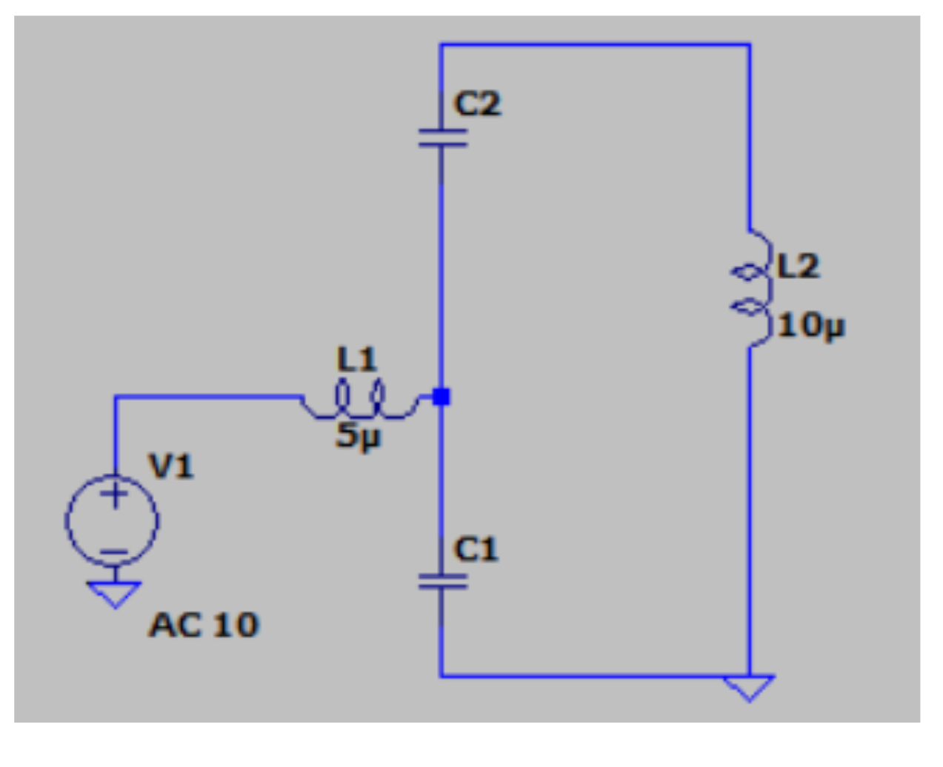

***Figure 4: Coil Driver Circuit Diagram (Secondary winding omitted for clarity)***

Where L2 is the primary winding of the tesla coil, modeled as a 10 µH inductor. The secondary winding is omitted from the diagram for clarity, but can be modeled as a parasitic resistance. The AC input V1 will be a pulse wave, generated by the MOSFET half-bridge connected to voltage rails. This circuit has two poles, one which has high current input and very high voltage gain, one with very low input current and medium voltage gain. We will use the second pole, in order to minimize load on the switching components. **Equations 1 and 2** can be used to detail this circuit: 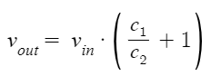

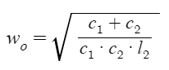

***Equations 1 & 2: Resonant Frequency and Output Voltage for Coil Driver***

In addition, in this scenario, input current is 0. This means that in a lossless circuit, power consumption is 0, and this current just sloshes around the tank, with no input current from the MOSFETS. Some current will occur due to parasitic losses and power transfer to the secondary winding, but this current will be due to real power dissipation, not reactive power dissipation. In this way, the MOSFETS will still output low current. In addition, a voltage gain is created in the primary winding in relation to the input. This allows us to run the circuit at lower voltage rails, and still maintain sparks in the secondary winding. Note that none of the values in the above equation depend on the inductance of L1. This will become important in a moment. There are two practical concerns when implementing a circuit like this. The first is to do with the fact that the input signal is a square wave, not a sine wave, and the second has to do with parasitic resistances.

Note that if we pick the fundamental frequency as we do above, and have an inductance of 0 for L1, as we raise the frequency, the circuit will behave more and more like a ground short to the input. Thus, if we input a square wave into this circuit, the efficiency at the fundamental will be very high, but harmonic distortion will cause an extremely high DC current to come from the power source, all of which is wasted. This is where L1 comes into play. Note that in ideal circumstances, no matter what the value of L1, the voltage gain is the same, as is the input current (0) and the frequency with this property. If L1 is high (or at least non-zero), higher harmonics contained in the square wave just won’t pass through. In this way, input current will be very low.

The second consideration here is parasitic resistances. Due to these resistances, the input current isn’t really zero, and after L1 reaches a certain size, voltage gain becomes non ideal. L1 can’t be too big, From simulation results, this value should be less than 5 microhenries. In addition, the ESR for C1 and C2 should be as small as possible, at least less than .05 ohms together. Another consideration here is voltage tolerances for the capacitors. Because of this voltage gain, C2 must be able to withhold a max voltage of (c1/c2) multiplied by the input AC voltage. If voltage rails are 60 V, and the gain ratio is 1:4 without losses, then C2 must be able to manage at least 240V AC voltage without breaking, so C2 will be designed to handle significantly more voltage than this, around 1kV, in order to prevent the capacitor from breaking. C1 can have a much lower voltage rating, as long as it can handle the power voltage rails.

The important part to note here is that all of these components have high tolerances for exact value. Regardless of value, a resonant frequency for the circuit exists, which can be calculated with the equation enumerated above. As long as the microcontroller can produce that frequency with high accuracy, the coil assembly will work ideally. Slight variations in capacitor values may affect voltage gain, but that doesn’t need to be exact, and as long as resonant frequency is in the low hundreds of megahertz, the surrounding circuit should be just fine.

It is important to note that we can model the power transmission to the secondary winding of the transformer as a parasitic resistance of the primary winding. This means that the above analysis should still work with the secondary winding in play, without meaningful variation from the above model.

The inductors in this circuit will be hand wound, they’re only a couple of turns. They will also be handling high current, so thick wire must be used. Simulations predicted the wires leading to the primary coil would draw a current of close to 40A, so the wire and the inductors should be designed to handle at least 1.5x this value or more. Therefore, the wire used should be able to handle at least 60 amps of current without breaking. Due to the properties of this circuit, the tolerances of the MOSFETs can be a little more flexible. Current gain is astronomic, so in an ideal scenario, there could be no more than 30 amps, possibly much less flowing through the MOSFETS. The subsystem must be designed to handle this current level, which can be done by sizing the components for current a factor of 1.5x or more than the expected current. The MOSFETs were also arranged using a parallel configuration in order to handle high current and protect from unanticipated current spikes, with two in parallel in series with another pair of two in parallel.These MOSFETS must also have DC blocking levels much higher than voltage rails, double would be preferable, so for 60V rails, that would mean a blocking voltage of around 120V. On-resistance of mosfets is also less important with this circuit topology, because comparatively low current is flowing into the tank.

The most important tolerance to support this circuit, however, is the microcontroller's granularity of output. This circuit is extremely frequency dependent. Below is a frequency response curve of the tank circuit with l1 removed, and parasitic resistances included. Blue is current in, green is voltage out. Note how current in has a minimum at ~358 kHz, and a maximum at ~354 kHz. These extremes are alleviated slightly with the inclusion of L1, but still remain. With Q values this high, the microcontroller needs to be able to output a variable pulse width wave with frequencies in the range 100k-400 kHz with granularity of ~500 hz. This is probably the most important specification of any element in our circuit. Note that even with parasitic resistance, a high Q value still exists. A well-sized L1 helps this somewhat in simulation, but the graph below shows how peak current and minimum current are in proximity to each other. Target parasitic resistance in the tank will definitely be less than an ohm, probably less than .1, or even .01 ohms, so this frequency granularity is crucial.

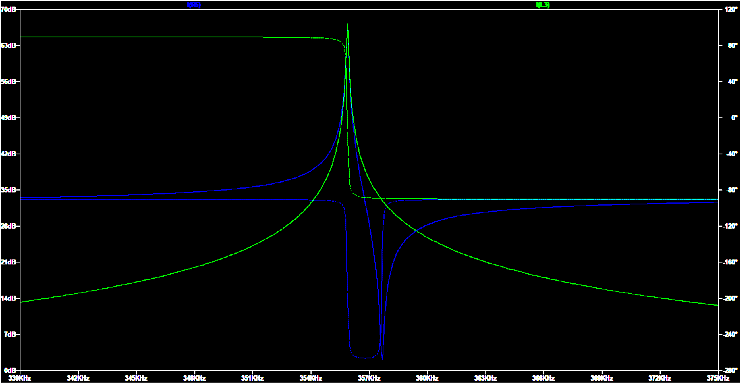

**III. Cost and Schedule:**

**High Level Cost Analysis:** Include a cost analysis of the project by following the outline below. Include a list of any non-standard parts, lab equipment, shop services, etc., which will be needed with an estimated cost for each.

| **Part(Expense)** | **Part Link** | **Cost** |
| --- | --- | --- |
| Fiber Optic Receiver IF-D95T | <https://www.digikey.com/en/products/detail/industrial-fiber-optics/IF-D95T/243780> | $9.18 |
| Fiber Optic Transmitter  IF-E96E | <https://www.digikey.com/en/products/detail/industrial-fiber-optics/IF-E96E/3461614> | $7.32 |
| Fiber Optic Cable  FM65025 | <https://www.digikey.com/en/products/detail/cliff-electronic-components-ltd/FM65025/20416282> | $5.10 |
| Power Entry Connector  6600.4315 | <https://www.digikey.com/en/products/detail/schurter-inc/6600-4315/569914> | $2.86 |
| Diode Rectifiers (10x)  637-1N4007 | <https://www.mouser.com/ProductDetail/637-1N4007> | $1.25 |
| 3-phase bridge rectifier (2x)  [637-DB35-10](https://www.mouser.com/ProductDetail/637-DB35-10) | <https://www.mouser.com/ProductDetail/637-DB35-10> | $9.86 |
| DC Power Connectors (5x)  [474-PRT-10811](https://www.mouser.com/ProductDetail/474-PRT-10811) | <https://www.mouser.com/ProductDetail/474-PRT-10811> | $4.75 |
| Cartridge Fuses (20x)  530-5SF10-R | <https://www.mouser.com/ProductDetail/Bel-Fuse/5SF-10-R?qs=sGAEpiMZZMsIz3CjQ1xega8hXO6fltfAeiYzrw%25> | $4.66 |
| Fuse Clips (10x)  [576-52000001009](https://www.mouser.com/ProductDetail/576-52000001009) | <https://www.mouser.com/ProductDetail/576-52000001009> | $1.67 |
| Circuit Breaker (2x)  562-QLB10311B3N3BA | <https://www.mouser.com/ProductDetail/Qualtek/QLB-103-11B3N-3BA?qs=vbU4ZYfMnUr53F0RHGXmWA%3D%3D> | $4.90 |
| Aluminum Electrolytic Capacitor  [80-ALC70A102EL500](https://www.mouser.com/ProductDetail/80-ALC70A102EL500) | <https://www.mouser.com/ProductDetail/80-ALC70A102EL500> | $21.02 |
| Gate Drivers (2x)  [634-SI82394CD4-IS](https://www.mouser.com/ProductDetail/634-SI82394CD4-IS) | <https://www.mouser.com/ProductDetail/634-SI82394CD4-IS> | $12.96 |
| MOSFET N-CH 650V 60A TO247 (4x) | <https://www.mouser.com/ProductDetail/637-1N4007> | $44.96 |
| Tesla Coil (provided) |  | Estimated $40 |
| ESP32 microcontroller | [https://www.digikey.com/en/products/detail/texas-instruments/MSP-EXP430G2ET/9608004](https://www.digikey.com/en/products/detail/texas-instruments/MSP-EXP430G2ET/9608004?utm_adgroup=&utm_source=google&utm_medium=cpc&utm_campaign=PMax%20Shopping_Product_Low%20ROAS%20Categories&utm_term=&utm_content=&utm_id=go_cmp-20243063506_adg-_ad-__dev-c_ext-_prd-9608004_sig-CjwKCAjw69moBhBgEiwAUFCx2KhN6xv4ME4FGpaxCwBC59nmOh7ZevAi3hTGl-CFXJNYRo-SjgzCLxoCEuMQAvD_BwE&gclid=CjwKCAjw69moBhBgEiwAUFCx2KhN6xv4ME4FGpaxCwBC59nmOh7ZevAi3hTGl-CFXJNYRo-SjgzCLxoCEuMQAvD_BwE) | $11.99 |
| TL074 op amp | <https://www.mouser.com/ProductDetail/Texas-Instruments/TL074CNE4?qs=odmYgEirbwzZM%2F3R%2FF4zPw%3D%3D> | $0.65 |
| Circuit Boards |  | ~$30 |
| Labor |  | Approximately $16,800 |
| Total |  | Approximately $17,000 |

**Labor Cost Analysis:**

Assuming 12 hours per week per person, each individual would be doing 12 * 14 = 168 hours of labor over the duration of the project.

| **Category** | | | **Estimated Hours per person** | | |
| --- | --- | --- | --- | --- | --- |
|  | | | Griffin | David | Aditya |
| Circuit Design and Construction | | | 67 | 67 | 67 |
| Testing and Debug | | | 100 | 100 | 100 |
| Logistics/Documentation | | | 15 | 15 | 15 |

Assuming an average hourly rate of $40 and that each person is doing 168 hours of work, then the total labor cost would come out to be approximately $16,800.

**Schedule:**

| **Dates/Week** | **Time** | **Task** | **Team Members** |
| --- | --- | --- | --- |
| Week of 9/25 (Week 6) | 12 hours | Finish all Schematics and the Simulation, Design Document, Ordering Power Components, Select Transistors and Switching ICs, Review and Feedback | David will look into the schematics and simulation before discussing it all amongst our team. Whole team will select components. Griffin will submit the order. The Design document will be done as a group. |
| Week of 10/2 (Week 7) | 12 hours | Review of the Design document, Rough draft of the power board(PCBWay) | David will design the power board and verify with the group. |
| Week of 10/9 (Week 8) | 12 hours | First PCB Order for the Power board, Test Power board upon arrival, Teammate evaluation #1 | David will order the power board and we will solder and test it as a group. Everyone will write their own Teammate evaluation. |
| Week of 10/16 (Week 9) | 12 hours | Design the Audio Processing board, Test Power board, Order another power board if deemed necessary | Griffin will design the audio board and verify with the group. Power board tests will be done as a group. |
| Week of 10/23 (Week 10) | 12 hours | Order Audio Processing board, Finish Individual progress report | Griffin will order the audio board, while progress reports are done individually. |
| Week of 10/30 (Week 11) | 12 hours | Test Audio Processing board with Power board, Debug, Review | Aditya will code the microcontroller for audio processing, and Griffin will test the audio PCB. |
| Week of 11/6 (Week 12) | 12 hours | Audio Processing, Test Tesla Coil Amp holistically, Debug, Review | David and Griffin will be in charge of holistically testing the tesla coil. Whole group will review the design. |
| Week of 11/13 (Week 13) | 12 hours | Debug, Review, Prepare for Demo, Mock Demo, Prepare for final presentation | Debug as a group, preparing for mock demo will also be done as a group. |
| Week of 11/27 (Week 14) | 12 hours | Debug, Review, Prepare for Final Demo, Final Demo, Prepare for final presentation | Further preparations and debugging also done as a group |
| Week of 12/4 (Week 15) | 12 hours | Final Presentation | Entire team presents |

**IV. Discussion of Ethics and Safety:**

**Ethics:**

Our group will act in accordance with the IEEE code of ethics. We understand that the technologies and parts that we are working with have the ability to affect one’s life. In our group, we have established a process to review and revise all software and hardware designs that will take everyone’s considerations into account. We will make sure to follow course guidelines for feedback and work with the head TA, Jason, closely. One ethical consideration that we need to take is not necessary with regards to our project, but with regards to making sure we treat everyone we work with with respect. We have taken steps to address this with open communication amongst our group members as well as our lead TA. Additionally, we have created a google drive with all of our research and design ideas, as that way everyone can access it and always give open feedback without the fear of their ideas not being taken into consideration. There aren’t too many ethical concerns with this project, but there are some concerns with the use cases of this project. We outlined that we expect this tesla coil to be used in a live music performance setting, and not in other industries such as the military. Other ethical concerns with this project involve user safety, however in the next section we outline our safety concerns and guidelines to make sure there is no harm or injuries.

**Safety:**

We have considered potential safety issues regarding the use and design of the Tesla Coil, and have outlined below precautions and safety measures that we will take in order to prevent any potential risks. According to IEEE Standard code, high voltages constitute voltages over 1kV[4]. Our control circuits do not reach voltage this high, however we do feel taking a number of these precautions is still necessary. The precautions taken are detailed in the list below.

It is important to note that the standard only applies to voltage sources “with sufficient energy to cause damage.” A capacitor of .05 µF with a voltage of 24 kV holds 14.4 joules of energy. At the frequency we are using, that will not be enough energy to penetrate human tissue. Likewise, although care should be taken in relation to all parts of the circuit, the most dangerous aspect of this circuit will be the DC power supply.

We will be following the Safety Guidelines set on the ECE 445 web page, as we have already all completed the Safety Training, and all plan to complete the extra training that is required for working with high currents. We have looked at the previous group to make a Tesla Coil, and are incorporating safety measures they took as well.

* The tesla coil will never be turned on indoors, it will be tested outside with multiple group members present using an outdoor wall outlet, with cones to create a circle of safety to keep bystanders away.
* We will keep everyone at least 10 ft away while the coil is active.
* The voltage can reach up to 100kV (albeit low current) so all sparks will be directed onto a grounding rod 3-5 cm away, as a general rule of thumb is each 30kV can bridge a 1cm gap [3].
* The coil will have an emergency stop button and a fuse at the power supply.
* The cable from the guitar will use a phototransistor so that the user is not connected to a circuit with any power electronics.
* We will have a grounding rod, so that we can ground the tesla coil after use so that it will be safe to handle after grounding
* In order to take extra precautions because we are working with high power and voltage, we will be using gloves when working with the Tesla Coil

**V. Citations:**

[1] J. Long; et al, “Improving the Musical Expressiveness of Tesla Coils with Software,” *University of North Texas,* Oct. 1, 2015. [Accessed Sep 27, 2023].

[2] E. Jones; A. Wright, “How Many Watts Can an Outlet Handle?” *Galvin Power,* Sep. 1, 2023. [Online]. Available: <https://www.galvinpower.org/how-many-watts-can-an-outlet-handle/>. [Accessed Sep 26, 2023].

[3] J. Papiewski, “How to Calculate Voltage by Spark Gaps,” *Sciencing,* Mar. 13, 2018. [Online]. Available: <https://sciencing.com/calculate-30-kw-amps-7644913.html>. [Accessed Sep 26, 2023].

[4]. IEEE Standards Board, “IEEE Recommended Practices for Safety in High-Voltage and High-Power Testing”, *IEEE Power Engineering Society,* Mar. 19, 1992. [Online]. Available: <https://ieeexplore.ieee.org/stamp/stamp.jsp?arnumber=578032>. [Accessed Oct 16, 2023].